A Report on

**Automatic Water Dispenser**

for

**Mini Project 1-a (REV- 2019 ‘C’ Scheme) of Second Year, (SE Sem-III)**

in

**Electronics & Telecommunication Engineering**

by

1. B-02 Divya Mokal
2. B-15 Aditi Patil
3. B-16 Kanchan Patil
4. B-17 Nikita Patil
5. B-21 Tejas Pote

Under the guidance of

**Prof. Ishmeet Singh Riar**



**UNIVERSITY OF MUMBAI**

**A. Y. 2020-21**

|  | **Mahatma Education Society’s**  **Pillai College of Engineering**  **Accredited A+ by NAAC**  **Dr. K. M. Vasudevan Pillai Campus,**  **Plot No. 10, Sector-16, New Panvel - 410206** |
| --- | --- |

**CERTIFICATE**

This is to certify that the project entitled **Automatic Water Dispenser is** a bonafide work of

1. B-02 Divya Mokal
2. B-15 Aditi Patil
3. B-16 Kanchan Patil
4. B-17 Nikita Patil
5. B-21 Tejas Pote

submitted to the University of Mumbai in partial fulfillment of the requirement for the award of **Mini Project 1-a (REV- 2019 ‘C’ Scheme) of Second Year, (SE Sem-III)** in **Electronics & Telecommunication Engineering** as laid down by **University of Mumbai** during academic year **2020-21**

| (_____________________) | (_____________________) |
| --- | --- |
| **Examiner/Reviewer-1** | **Examiner/ Reviewer -2** |

|  |  |  |
| --- | --- | --- |
| **Prof. Ishmeet Singh Riar** | **Dr. Avinash Vaidya** | **Dr. Sandeep Joshi** |
| **Guide** | **Head of Department** | **Principal** |

**ABSTRACT**

Water scarcity is the major problem which the major cities are facing across the world. About 71% of earth is covered with water but sadly only 2.5% of it is drinking water. At one hand there are already minor disputes among nations and states for sharing river water and on the other hand we as humans waste a lot of drinking water due to our negligence. It might not appear big at first time, but if your tap dripped a drop of water once every second it would take only about five hours of you to waste one gallon of water.

 The automatic water dispenser has a function of supplying and stopping a certain amount of water by using relay, and, is capable of automatically supplying water using a sensor without using a button. Unlike an existing automatic water dispenser, the automatic water dispenser adopts a way of operating a water tap directly with a mechanical mechanism by driving a motor without using a solenoid valve for completely opening and closing the water tap. As such, a simple replacement of the water tap of the existing water dispenser with the present system not only adds more advanced functions than the expensive automatic water dispensers but also ensures the same or higher flow rate performance than the existing dispenser.

Thus, if we replace all the manual taps with a smart one that opens and closes on its own automatically not only we can save water but also have a healthier lifestyle since we don’t have to operate the tap with our dirty hands. So, in this project we will build an Automatic Water Dispenser using IR sensor that can automatically give you water when a glass is placed near it.

**LIST OF FIGURES**

| **Figure No.** | **Name of the figure** | **Page No.** |
| --- | --- | --- |
| 4.1 | Block diagram of Sensor | 5 |
| 4.2 | Block diagram of Controller | 6 |
| 4.3 | Circuit diagram of part 1 | 6 |
| 4.4 | Circuit diagram of part 2 | 7 |
| 5.1 | IR sensor | 10 |
| 5.2 | DC Motor | 10 |
| 5.4 | 7805 Voltage regulator | 11 |
| 5.5 | 12V SPDT Relay | 12 |
| 5.6 | Step Down Transformer | 12 |
| 5.7 | Proteus Software | 14 |
| 6.1 | Schematic Diagram of dispenser part in Proteus | 15 |
| 6.2 | Schematic Diagram of indicator controller part in Proteus | 16 |
| 7.1 | Simulation result of part 1 | 17 |
| 7.2 | Simulation result of part 2 | 18 |

**LIST OF TABLES**

| **Table**  **No.** | **Table Title** | **Page No.** |
| --- | --- | --- |
| 4.1 | Hardware Components | 9 |

**INDEX**

| **CONTENTS** | | | | |
| --- | --- | --- | --- | --- |
| Certificate | | …………………………………………………………………... | | i |
| Abstract | | …………………………………………………………………... | | ii |
| List of Figures | | …………………………………………………………………... | | iii |
| List of Tables | | …………………………………………………………………... | | iv |
| Abbreviation | | …………………………………………………………………... | | v |
| List of Symbols | | …………………………………………………………………... | | vi |
|  | |  | |  |
| 1. | Introduction ………………………………………………………………….  1.1 Automatic Water Dispenser | | | 1 |
| 2. | Literature Review……………………………………………………………. | | | 2 |
| 3. | Problem Statement ……………………………………………......................  3.1 Need  3.2 Objectives | | | 3 |
| 4. | Principle and Working ………………………………………………………  4.1 Block diagram  4.2 Circuit diagram | | | 5 |
| 5. | Component Description ………………………………………......................  5.1 Hardware  5.2 Software | | | 9 |
| 6. | Software Implementation …………………………………………………… | | | 15 |
| 7. | Simulation Results …………………………………………………………. | | | 17 |
| 8. | Conclusions …………………………………………………………………. | | | 19 |
| 9. | Future Scope …………………………………………………....................... | | | 20 |
| References | | | ……………………………………………………....................... | 21 |
| Appendix | | | ……………………………………………………....................... | 22 |

**CHAPTER 1.**

**INTRODUCTION**

This chapter gives basic introduction about the working of the project. Automatic water dispenser- As the name says, its automatic due to the sensor present and releases water without much manual labor.

* 1. **AUTOMATIC WATER DISPENSER**

Its 3 features are: Switches, sensors and rechargeable battery. This project titled automatic water dispenser is a modern approach to the conventional water dispenser that we use in our daily life. In this system we have used a switch which is connected to a relay which controls the water motor which acts as a valve to control the water flow to the tap. The water dispensers that we use in our daily life are mechanically operated. The water flows through the tap when we keep the object near IR Sensor and the water flow stops once we remove the object. There is no button system so no water loss and wear and tear of the button takes place and therefore the dispenser maintenance is inexpensive. This can make the dispenser handy and user friendly by giving it an electronic touch. We are using the IR sensor technology and making the machine far advanced than its counterparts.

The need of automatic water dispenser system and how it can be achieved is discussed in the report. Different methods and its advantages are discussed to supply water automatically

with increased performance. The conclusion and future scope are discussed in further section.

The proposed system gives the automatic dispensing, indication and control of water. Here, the manual technique of opening and closing of the valves in the existing system is reduced. The controller controls the flow of water and the indicator indicates it using the LED’s. If the water is at high level the green LED glows and the motor is automatically turned OFF.

**CHAPTER 2.**

**LITERATURE REVIEW**

This chapter gives the information about the literature review:

"Smart Water Dispenser and Monitoring Water Level in IoT and Android Environment" According to this research paper the working of the entire system can be represented with the sensor connected to the water dispenser. It ON’s and OFF’s automatically. The sensor checks the water level and sends signals to the Arduino Uno micro controller. If tank is empty then it sends the notification about the water level. The data is sent as a push notification to the authorized user. The sensor checks the level of water if tank is empty, it will send a notification by using IOT devices or sensors. Then the user will access the received message about taking necessary action. An automatic water dispenser using node microcontroller unit and ultrasonic sensor. It will replace all manual taps with a smart one that opens and closes on its own, automatically.

"Automatic Indoor Water Dispensing Machine”. It consists of the following major units: power supply unit, object sensing unit, overflow sensing unit, microcontroller unit and the

output unit. The step-down transformer in power unit steps down alternating current. The object sensing unit emits ultraviolet rays and transmits it to the photo diode that detects it. The overflow sensing unit sends a voltage to bias the transistor and a HIGH signal is sent to the microcontroller to close the solenoid valve. The microcontroller unit is programmed to receive input from the object sensing unit and act on the input based on the installed program and send signals to operate the output unit. The output unit receives a high signal and closes when it receives a low signal.

These are the two research papers which we have referred for our project.

**CHAPTER 3.**

**PROBLEM STATEMENT**

Usually, most of the water tap in the market use old system where it uses manual control to turn on or turn off the system. When the users use that system, they must use their hand to open or close the water tap and the water tap valve is easy to damage because the users always turn strongly to open or close the tap. This system is not efficient because water wastage is easy to occur because at the time between to open the tap and wash their hand the water has already been wasted. It’s same when we want to close it and if we forgot to close the water tap it will make wastage of water more critical. As we can see usage of sink only focuses on one usage it is all about water, looking at the development of technology today usage of sink should not be focused on water use only because user’s need something which can give many benefits when they use it. Another disadvantage for this system is when users wash their hands, their hands are not very clean because they still have a direct contact to the messy water tap where it exposes to the bacteria. In day-to-day life, water is very essential for public, so there is a requirement of avoiding wastage of drinking water. To overcome this problem Automatic water dispenser can be solution to it.

1. **NEED**

The automatic water dispenser is such a machine which is capable of making the human work a lot easier. It plays vital role in workplaces, restaurants, hospitals, and public places for storing clean drinking water.

* It offers safe, clean and purified drinking water.
* The appliance keeps your family hydrated and active all day long.
* Tastes better than normal.
* Better for your health.

1. **OBJECTIVES**

* To design and implement automatic water dispenser pouring machine.
* To reduce wastage of water that always occurs at water taps.
* To reduce direct contact to the device for prevention from bacteria.
* To study and learn the type and characteristics of motor and sensor.
* To learn about the relay function.
* Control the water level in the main tank. When the water level is very low an LED will

start glowing and the motor connected with the external water tank will then start

pumping the water in the main tank. When the level of water reaches a predefined level

then the motor is turned off.

* In this project our main concentration is to manage the water dispenser by measuring the water levels. The system monitors the water dispenser by IR sensor placed over the dispenser and compare the level with threshold volume of the dispenser. The main goal of our project is to monitor the water level and manage the overall water dispenser. It will provide faster, easier, and cost-effective management. It also includes the design of monitoring system with advantages of low cost and accuracy.

**CHAPTER 4.**

**PRINCIPLE AND WORKING**

This chapter gives the information about the principal and working of our project.

This project titled automatic water dispenser is a modern approach to the conventional water dispenser that we use in our daily life.In this system we use an IR Sensor which is connected to a NPN transistor which controls the motor which acts as a valve to control the water flow to the tap. It switches the motor on whenever the water level drops below a certain level and shuts the motor off when the water rises well above a fixed level.

1. **BLOCK DIAGRAM**

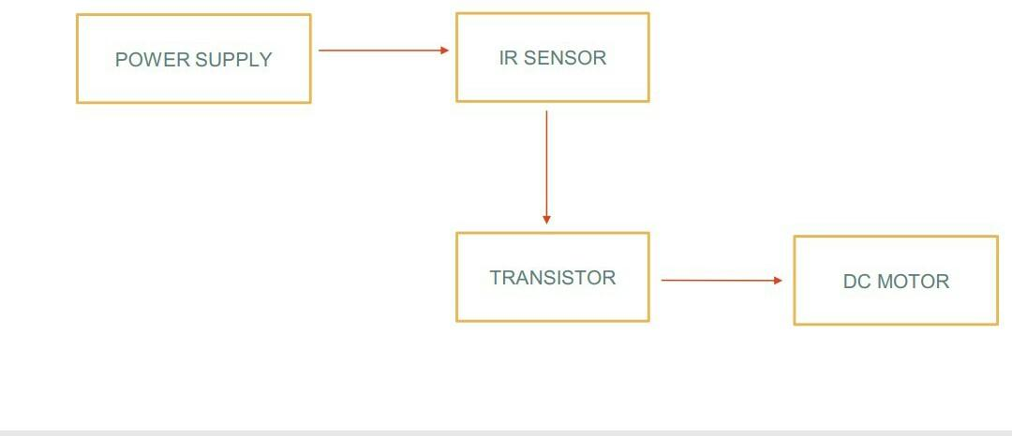

Fig 4.1 Block diagram of Sensor Part

The fig 4.1 shows the block diagram of part 1 of the circuit i.e., the Sensor part. It consists of power supply, IR Sensor, transistor and DC Motor.

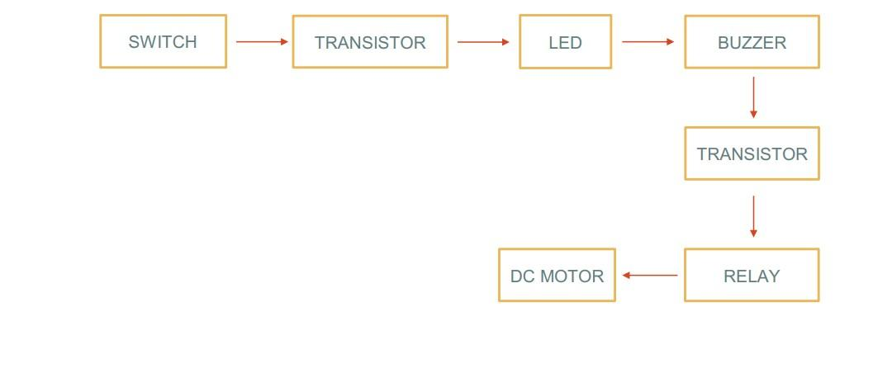

Fig 4.2 Block Diagram of Controller Part

The fig 4.2 shows the block diagram of part 2 of the circuit i.e., controller part. It consists of switch, transistor, LED, buzzer, transistor, relay, DC motor.

1. **CIRCUIT DIAGRAM**

**PART I: Sensor Part**

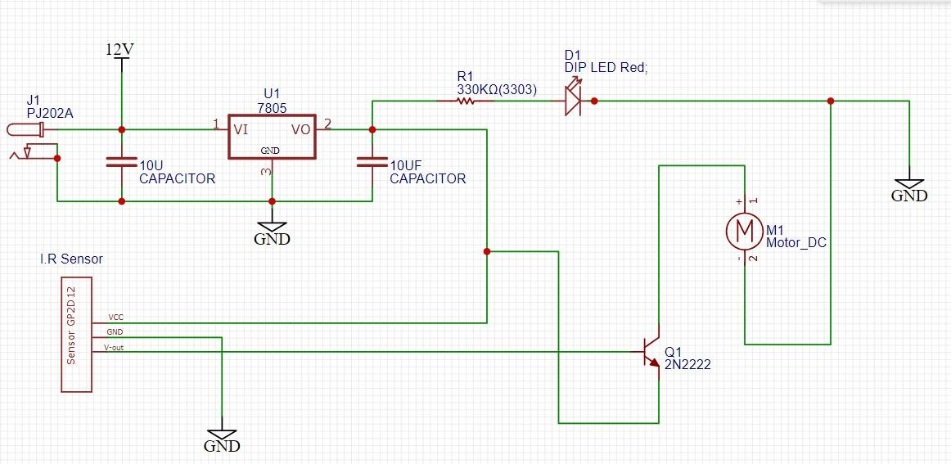

Fig 4.3 Circuit Diagram of Part 1

The main function of a transformer is to transfer AC electrical power from one circuit to another circuit while keeping the frequency level constant but with altered voltage, which means it increases or decreases the voltage based on the requirement of the machines. A Step-Down Transformer is the one which reduces the output voltage that means it functions for converting high voltage with low current into a low voltage with high current. The working of the device is quite simple, the main components involved are transistor, voltage regulator, motor and I.R sensor. Power Supply is given to the voltage regulator. The resulting voltage available at the output of the voltage regulator energizes the I.R sensor. A sensor basically works on the change in the input quantity being measured, for instance if we consider I-R (infrared) sensor, it is triggered only when an object cuts the line of the infrared beam. The I.R sensor detects the presence of objects in the close vicinity of the sensor and sends the signal to the transistor which performs the switching action and supplies power to the motor so that the valve opens and the led glows. The flow of water will stop when we remove the object.

**PART II: Controller Part**

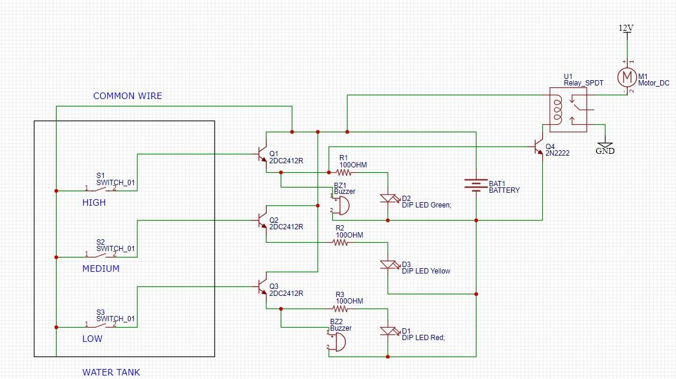

Fig 4.4 Circuit diagram of part 2

A water level indicator may be defined as a system by which we can get the information of water level within the reservoir. The operation of water level controller works upon the fact that water conducts electricity due to presence of minerals within it. Thus, water in the tank can be used to close a circuit. As the water level rises, different circuits in the controller send different signals. In the project we have used four probes which are adjusted at four different levels in such a way that the three of them are used to sense the three levels high, medium and low respectively of water in the tank. The fourth probe is used as common and reference level to the three probes. In this project we have also used three LED indicators namely Red (LOW), (Medium) and Green (High) and two buzzers parallel to the green and red LED’s which are connected to the three transistors. The four segments of insulated conducting probes are immersed within the water tank by placing their naked ends at various above-mentioned levels with the help of a rod. Once the high level is sensed by probe in the water tank, the green LED blink and the buzzer buzzes indicating the tank is completely filled which in turn automatically switches the motor off by the relay switching mechanism so as to avoid wastage of water.

**CHAPTER 5.**

**COMPONENT DESCRIPTION**

The circuit for this project can be referred from the Fig. 4.1and 4.2 which gives an overview of how the connections of the necessary components are made so as to achieve the automated system to dispense the water and to indicate and control water level & avoid its wastage.

This chapter gives information about the hardware components and software used in our project.

1. **HARDWARE**

**Table 5.1 Hardware Components**

| **Sr no.** | **Name of the component** | **Value** |
| --- | --- | --- |
| 1 | IR Sensor | LM358 Obstacle Sensor |
| 2 | DC Motor | Micro DC 12V Submersible Pump Mini water pump |
| 3 | Voltage regulator | LM7805 5V |
| 4 | LED’s | Green , Yellow, Red |
| 5 | Transistor | 2N2222 NPN |
| 6 | Relay | SPDT 12V DC SRD-12VDC-SL-C 5 Pin Sugar Cube Relay(G5LE) – Original Songle |
| 7 | Transformer | 230V 50hz Input DC 23V 400mA |
| 8 | Resistor | 330Ω & 100Ω & 1kΩ |
| 9 | Power Jack | PJ202A |
| 10 | Buzzer | 6V |
| 11 | Capacitor | 10uF |

Table 5.1 shows the hardware components used in our project. Below are some of the major components used:

**IR SENSOR:** An infrared sensor is an electronic device, that emits in order to sense some aspects of the surroundings. An IR sensor can measure the heat of an object as well as detects the motion. In our project, IR sensor is used as an object detector. The basic concept of an Infrared Sensor which is used as Obstacle detector is to transmit an infrared signal, this infrared signal bounces from the surface of an object and the signal is received at the infrared receiver. Supply input for the IR Sensor is 3.3 to 5V.

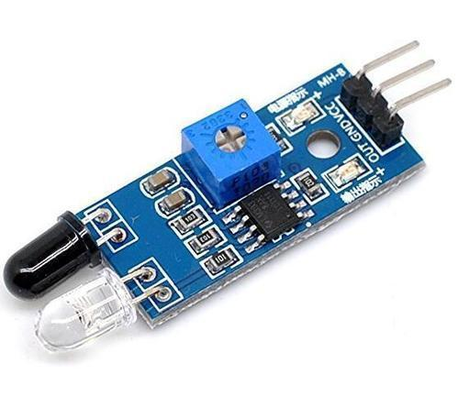

Fig 5.1 IR Sensor

**MOTOR :** A DC motor converts DC electrical energy into mechanical energy. When a magnetic field and an electric field interact, a mechanical force is produced. The DCmotor or direct current motor works on that principle. This is known as motoring action.

The direction of rotation of this motor is given by [Fleming’s left hand rule](https://www.electrical4u.com/fleming-left-hand-rule-and-fleming-right-hand-rule/), which states that if the index finger, middle finger, and thumb of your left hand are extended mutually perpendicular to each other and if the index finger represents the direction of the magnetic field, middle finger indicates the direction of the current, then the thumb represents the direction in which force is experienced by the shaft of the DC motor. In our project, we used two motors. Number of winding turns per phase are 90 Nph. Efficiency of the motor is 87.8%. The drive frequency of the motor is 50Hz.

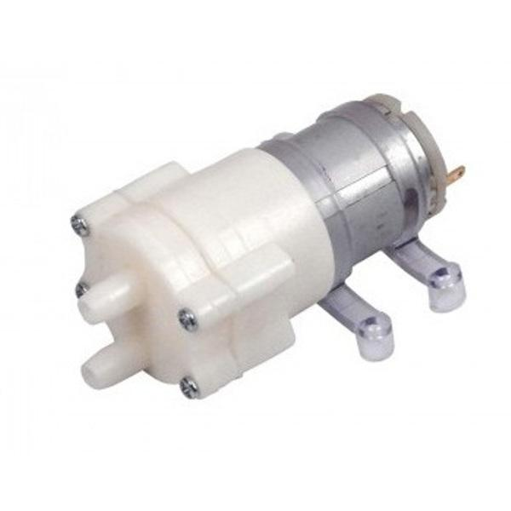

Fig 5.2 DC Motor

**VOLTAGE REGULATOR:** A voltage regulator is a system designed to automatically maintain a constant voltage level. A voltage regulator may use a simple feed-forward design or may include negative feedback. It may use an electromechanical mechanism, or electronic components. Depending on the design, it may be used to regulate one or more AC or DC voltages. In our project, we used LM7805 to regulate DC voltage 12V to 5V.

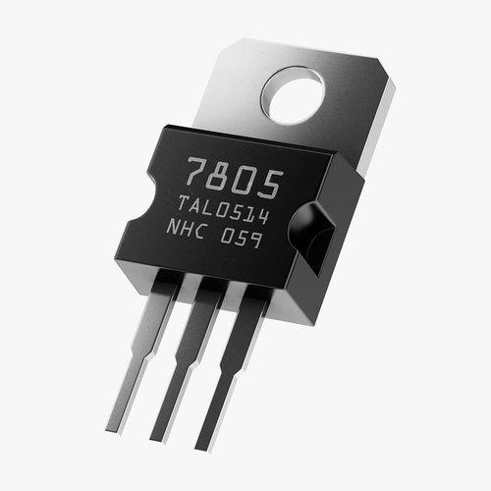

Fig 5.3 7805 Voltage Regulator

**RELAY:** Relay is an electro-mechanical switch used to control high power application through low power signal electronic circuits. We have used 12V SPDT relay to control the operation of motor. Single Pole Double Throw (SPDT) Relay contains two coil terminals and common terminal, then two switching terminals N/O (Normally Open), N/C (Normally Close). If there is not enough DC supply in coil terminals, then Relay represents idle condition that is common terminal connected in N/C terminal. When the coil gets required DC supply then coil gets Magnetically Energized and this magnetic flux force attracts common terminal lever which is made of iron and makes the connection to N/O terminal, now the N/C becomes open.

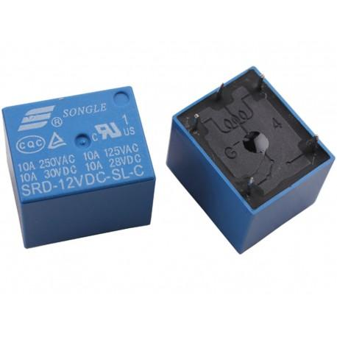

Fig 5.4 12V SPDT Relay

**TRANSFORMER:** A transformer is a static electrical machine which transfers AC electrical power from one circuit to the other circuit at the constant frequency, but the voltage level can be altered that means voltage can be increased or decreased according to the requirement. A step-down transformer is a [type of transformer](https://www.electrical4u.com/electrical-power-transformer-definition-and-types-of-transformer/) that converts the high voltage(HV) and low current from the primary side of the transformer to the low voltage (LV) and high current value on the secondary side of the transformer. A step-down transformer is used to provide this low voltage value which is suitable for electronics supplying. It transforms home voltage (230/120 V) from primary to a low voltage on the secondary side which is used for electronic supplying. In this project, we have used a step-down transformer which steps down from 230V to 23V.

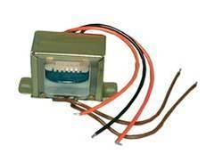

Fig 5.5 Step Down Transformer

**5.2 SOFTWARE**

For our project, we have used ISIS Proteus for simulation. The Proteus Design Suite is a proprietary software tool suite used primarily for electronic design automation. It is developed in Yorkshire, England by Labcenter Electronics Ltd with offices in North America and several overseas sales channels. The software runs on the Windows operating system and is available in English, French, Spanish and Chinese languages.

The first version of what is now the Proteus Design Suite was called PC-B and was written by the company chairman, John Jameson, for DOS in 1988. Schematic Capture support followed in 1990, with a port to the Windows environment shortly thereafter. Mixed mode SPICE Simulation was first integrated into Proteus in 1996 and microcontroller simulation then arrived in Proteus in 1998. Shape based auto routing was added in 2002 and 2006 saw another major product update with 3D Board Visualization. More recently, a dedicated IDE for simulation was added in 2011 and MCAD import/export was included in 2015. Feature led product releases are typically biannual, while maintenance-based service packs are released as required.

The Proteus Design Suite is a Windows application for schematic capture, simulation, and PCB layout design. It can be purchased in many configurations, depending on the size of designs being produced and the requirements for microcontroller simulation. All PCB Design products include an auto router and basic mixed mode SPICE simulation capabilities. The software is used mainly by electronic design engineers and technicians to create schematics and electronic prints for manufacturing printed circuit boards. The Proteus Design Suite is a Windows application for schematic capture, simulation, and PCB (Printed Circuit Board) layout design.

Schematic capture in the Proteus Design Suite is used for both the simulation of designs and as the design phase of a PCB layout project. It is therefore a core component and is included with all product configurations. Proteus is a virtual system modelling and circuit simulation application. The suit combines mixed mode SPICE circuit simulation, animated components and microprocessor models to facilitate co-simulation of complete microcontroller-based designs.

Schematic capture in the Proteus Design Suite is used for both the simulation of designs and as the design phase of a PCB layout project. It is therefore a core component and is included with all product configurations. The micro-controller simulation in Proteus works by applying either a hex file or a debug file to the microcontroller part on the schematic. It is then co-simulated along with any analog and digital electronics connected to it. This enables it's used in a broad spectrum of project prototyping in areas such as motor control, temperature control and user interface design. It also finds use in the general hobbyist community and, since no hardware is required, is convenient to use as a training or teaching tool.

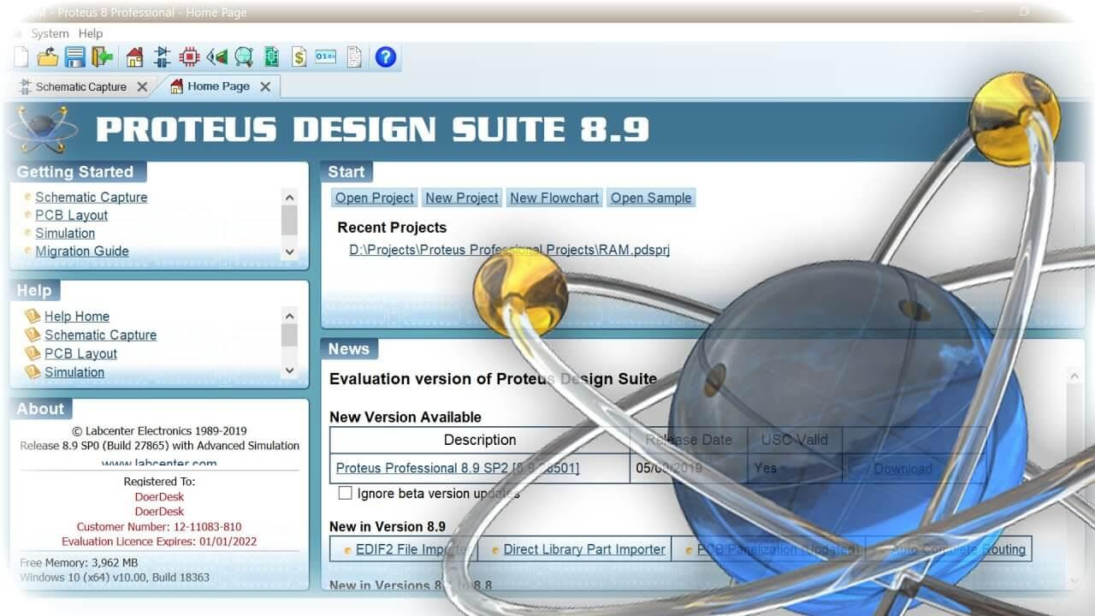

Fig 5.6 Proteus Software

**CHAPTER 6.**

**SOFTWARE IMPLEMENTATION**

This chapter gives information about software implementation of our project.

Conventionally designing process requires only the estimation based on theoretical understanding. With the help of assisted software, simulation can be done. From this simulation result, it gives the guideline flexibility to refine the circuit for example the outcome or the result does not satisfy the requirement. For this project, Proteus software is used. This software not only helps to speed up the process of designing, but also avoid unnecessary mistake before the actual thing is build.

ISIS Proteus simulation is a software tool that can design a schematic diagram and make a simulation of the circuit. It is easy to use this program because we can design our own circuit and simulate it. We can check if the simulations work properly or not and make changes accordingly. We have made two circuits, the first one, is about dispensing of water and second part, is about indication and controlling of the water as shown in the fig 6.1 and fig6.2. We had to add libraries for some missing component like IR Sensor. It can simulate entire IR Sensor design circuits without programming. We assembled the components according to the circuit diagram shown in fig 2. After the assembling the components and completing the circuit, we simulated the circuits to observe the results.

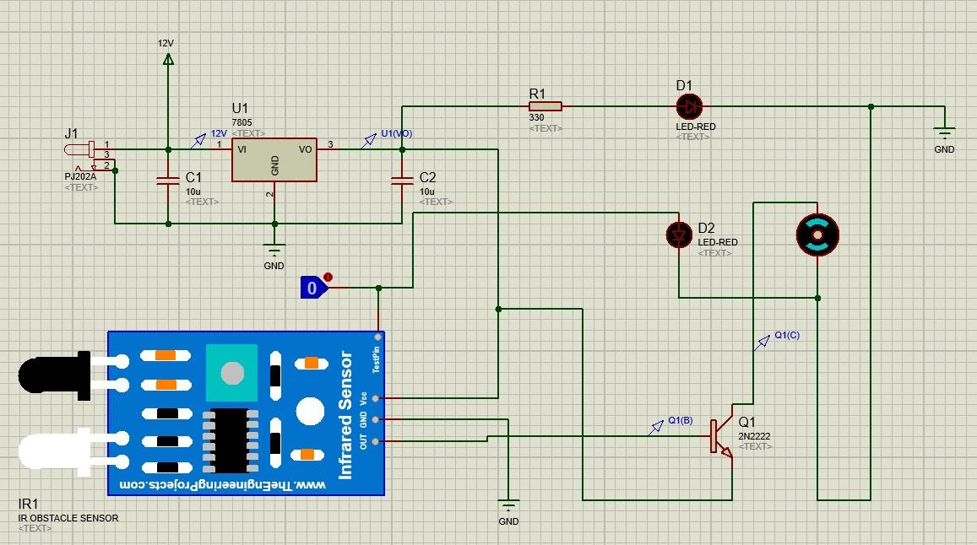

Fig 6.1 Schematic Diagram of dispenser circuit in Proteus

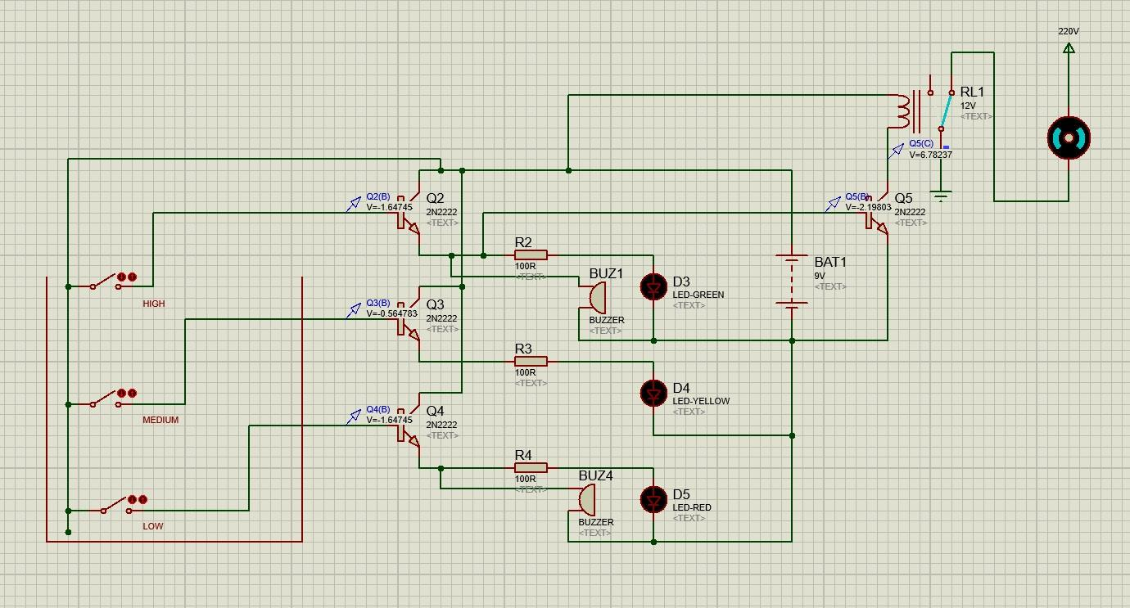

Fig 6.2 Schematic Diagram of indicator and controller circuit in Proteus

**CHAPTER 7.**

**SIMULATION RESULTS**

This chapter shows the simulation results of our project.

**PART 1:**

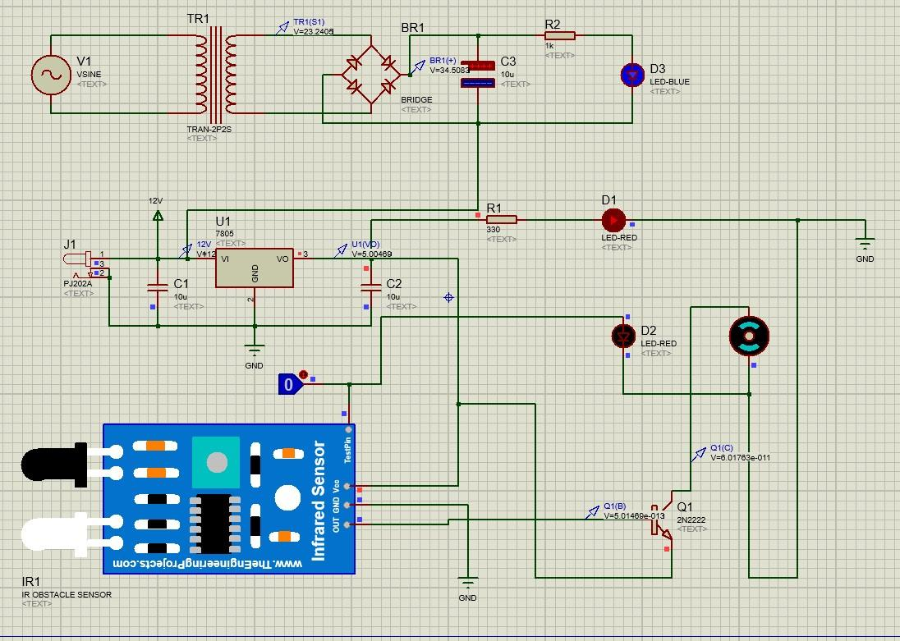

Fig 7.1 Simulation result of part 1

Fig 7.1 shows the simulation results of part 1 i.e., Sensor part of the project which represents that the IR sensor which detects the presence of objects in the close vicinity of the sensor and sends the signal to the transistor which performs the switching action and supplies power to the motor so that the valve opens and led glows. The flow will stop when we remove the object

**PART 2:**

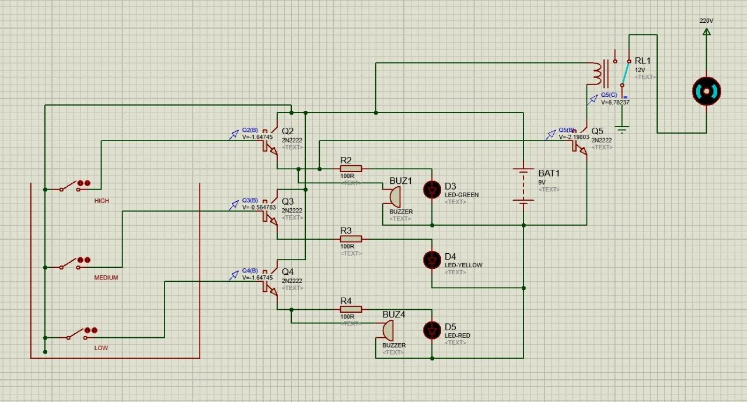

Fig 7.2 Simulation result of part 2

Fig 7.2 shows the simulation results of part 2 i.e., the controller part of the project which represents that once the high level is sensed by probe in the water tank, the green LED blinks and the buzzer indicates that the tank is completely filled which in turn automatically switches the motor OFF by the relay switching mechanism so as to avoid wastage of water.

When the low level is sensed by probe in the water tank, the red LED blinks and the buzzer indicates that the tank is at low level which in turn automatically switches the motor ON by the relay switching mechanism. When the medium level is sensed by probe in the water tank, the yellow LED blinks it indicates that the tank is at medium level which in turn automatically switches the motor ON by the relay switching mechanism.

**CHAPTER 8.**

**CONCLUSIONS**

The automation of the water distribution system eliminates not only water wastage but also provides continuous water flow according to the set point. This project is automatic so it reduces lots of manpower. The automatic water distribution system ensures to avoid wastage of water and reduces time. And also, we can completely avoid stealing of water in the pipelines. So that people could get an equal share of water. This system is excellent and cost effective. It is the best way to prevent the drinking water from the theft.

Moreover, it causes no effect on nature i.e., pollution free, at the same time not prone to any kind of accident due to lightning and highly suitable for domestic purposes. By using this system people can save electricity charge and very less maintenance charge to this equipment is required. There is no power failure or load shedding situation at any times. Therefore, it is the most reliable renewable power or electricity resource with the least expenditure in the globe.

It reduces the energy and time. It is suitable for use at home, school and can be placed in private room. This project is to design and develop an automatic water dispenser that is suitable for various kind of container. This study presents the design phase of Water Level Monitoring System in Water Dispensers using IR sensor. The requirement analysis and the system design detail have been conducted in depth for the better understanding of the project and also to know risk factors that will be faced during the construction phase. From the above analysis we can conclude that the entire system can be built with low cost, reliable instruments thereby providing an efficient Water Level Monitor and Sensor.

**CHAPTER 9.**

**FUTURE SCOPE**

The proposed system is the design of automatic water dispenser and water level monitoring using IR Sensor. There is no limitation for improvisation, different ideas can reflect the changes in the way it is implemented.

In future we can replace IR Optocoupler sensor by photo detective sensors to make the system for limited or particular detection. Image processing technique is best for this system. We can also use filter for purification of water. We can interface system with keyboard. That enables people to interact with it when buying water. When it will be commercialized it could be deployed to various areas in the world. We can make use of Arduino to build thread system of automatic water dispenser. Also, there are microcontrollers which we can work in. In future the best of android app can get notification for the system. Along with this system it is possible to implement the water TDS, water temperature, and automatic ejection of water from the tap this process is done without any need of human interference in future.

The main goal of proposed system is to monitor the water level and manage the overall dispensers. It will be very useful in this COVID-19 situation. The social distancing will be maintained as well. So, from the above analysis we can say that the entire system can be built at low cost thereby providing an efficient water quantity monitoring system in water dispensers using smart taps. In future the all-smart taps will be replaced by faucets taps.

**REFERENCES**

1. Ajinkya Kaner, Milind Rane, Automatic Water Level Indicator & Controller (To control water level of overhead tank), International Journal of Advanced Research in Electronics and Communication Engineering (IJARECE) Volume 6, Issue 11, November 2017, Vishwakarma Institute of Technology, Pune.
2. www.electronics-tutorials.ws/diode/diode_6.html
3. www.electroinvention.co.in/automatic-water-pump-controller
4. create.arduino.cc/projecthub/creatjet3d-r-d-team/arduino-based-automatic-water-tap-using-ir-sensor-7e6496
5. hyclassproject.com/design-and-construction-of-coin-based-water-dispenser-system.html
6. Mr.Akash Chowdry, Mr.Prathap S Gautham, Dwarakanath S K, Automatic Water Dispenser, Journal of Control and Instrumentation Engineering Volume 4 Issue 3, SJB Institute of Technology, Bengaluru, Karnataka, India.
7. Anuradha , Shweta Jadhav, Sridevi Mahamani, Smart Water Dispenser and Monitoring Water Level in IoT and Android Environment, International Journal of Computer Sciences and Engineering Research Paper Vol.-7, Issue-5, May 2019.
8. Igbinoba, C.K. and Okhaifoh, J.E., Automatic Indoor Water Dispensing Machine, Nigerian Research Journal of Engineering and Environmental Sciences 4(1) 2019 pp. 460-467.

**APPENDIX**

**IR SENSOR:**

| **Pin, Control Indicator** | **Description** |
| --- | --- |
| Vcc | 3.3 to 5 vdc Supply Input |
| Gnd | Ground Input |
| Out | Output that goes low when obstacle is in range |
| Power LED | Illuminates when power is applied |
| Obstacle LED | Illuminates when obstacle is detected |
| Distance adjust | Adjust detection distance. CCW decreases distance. CW increases distance. |
| IR Emitter | Infrared emitter LED |
| IR Receiver | Infrared receiver that receives signal transmitted by Infrared emitter. |

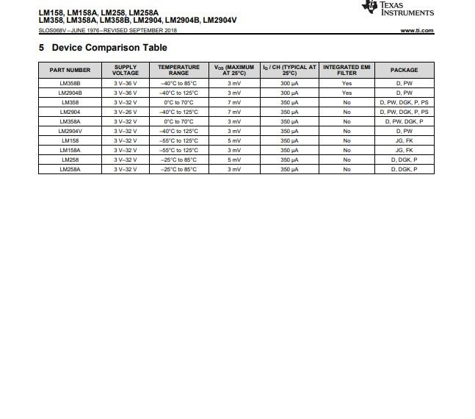

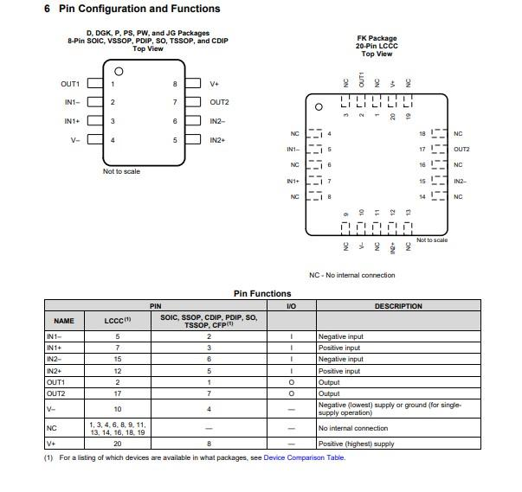

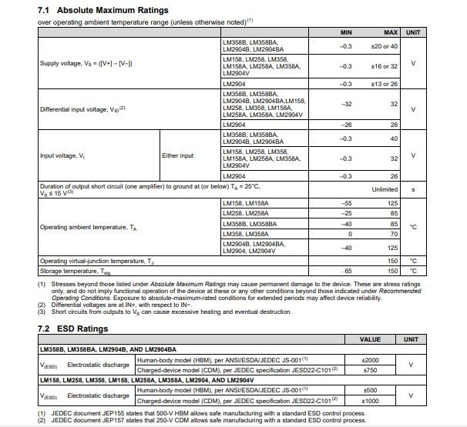

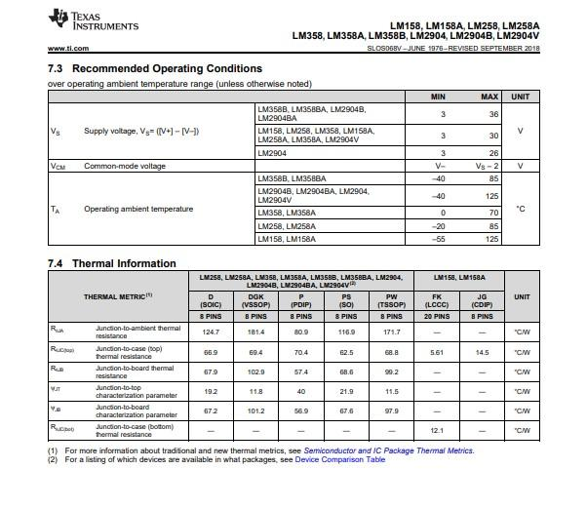

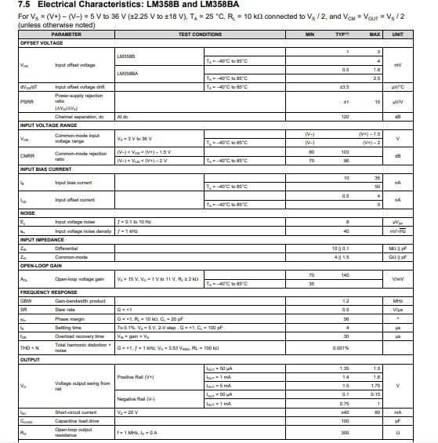

**MOTOR:**

| **Parameter** | **Units** | **Value** |
| --- | --- | --- |
| Nominal voltage | Vnom | 70v |
| Nominal power | Pnom | 1kW |
| Number of pole pairs | p | 2 |
| Number of phases | m | 3 |
| Drive frequency | f | 50 |
| Efficiency | ɳ | 87.8% |
| Outer Diameter | Do | 170mm |
| Inner Diameter | Di | 80mm |
| Inner to Outer Diameter’s Ratio | λ | 0.47 |
| Magnet’s axial length | Lpm | 2.5mm |
| Pole pitch | γp | 118degree |
| Stator-yoke thickness | 2×Lcs | 30mm |
| Rotor-yoke thickness | Lcr | 11mm |
| Slot Width | Ws | 10mm |
| Slot Depth | Ds | 16mm |
| Number of slots | Ns | 15 |
| Number of winding turns per phase | Nph | (15×18)/3 |
| Air-gap Flux Density | Bg | 0.47T |
| Air-gap length | g | 1mm |

